Kingdom of Saudi Arabia  Ministry of Education  Prince Sattam Bin Abdulaziz University  College of Computer  Engineering and sciences  Department of Computer Sciences |  | وزارة التعليم  جامعة الامير سطام بن عبد العزيز  كلية هندسة وعلوم الحاسب  قسم علوم الحاسب

CS 4831 - Mobile Application Development
Year 26-27 Sem1
Lab Exrecise 2
- Design the following linear Layout for student registration
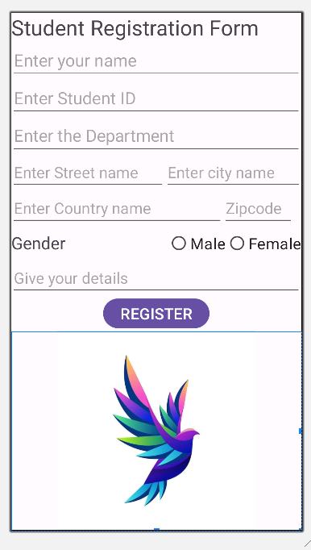

Use the following image for logo :



Upload the word file with the activity design and XML code.

